Celeriac Information Pack
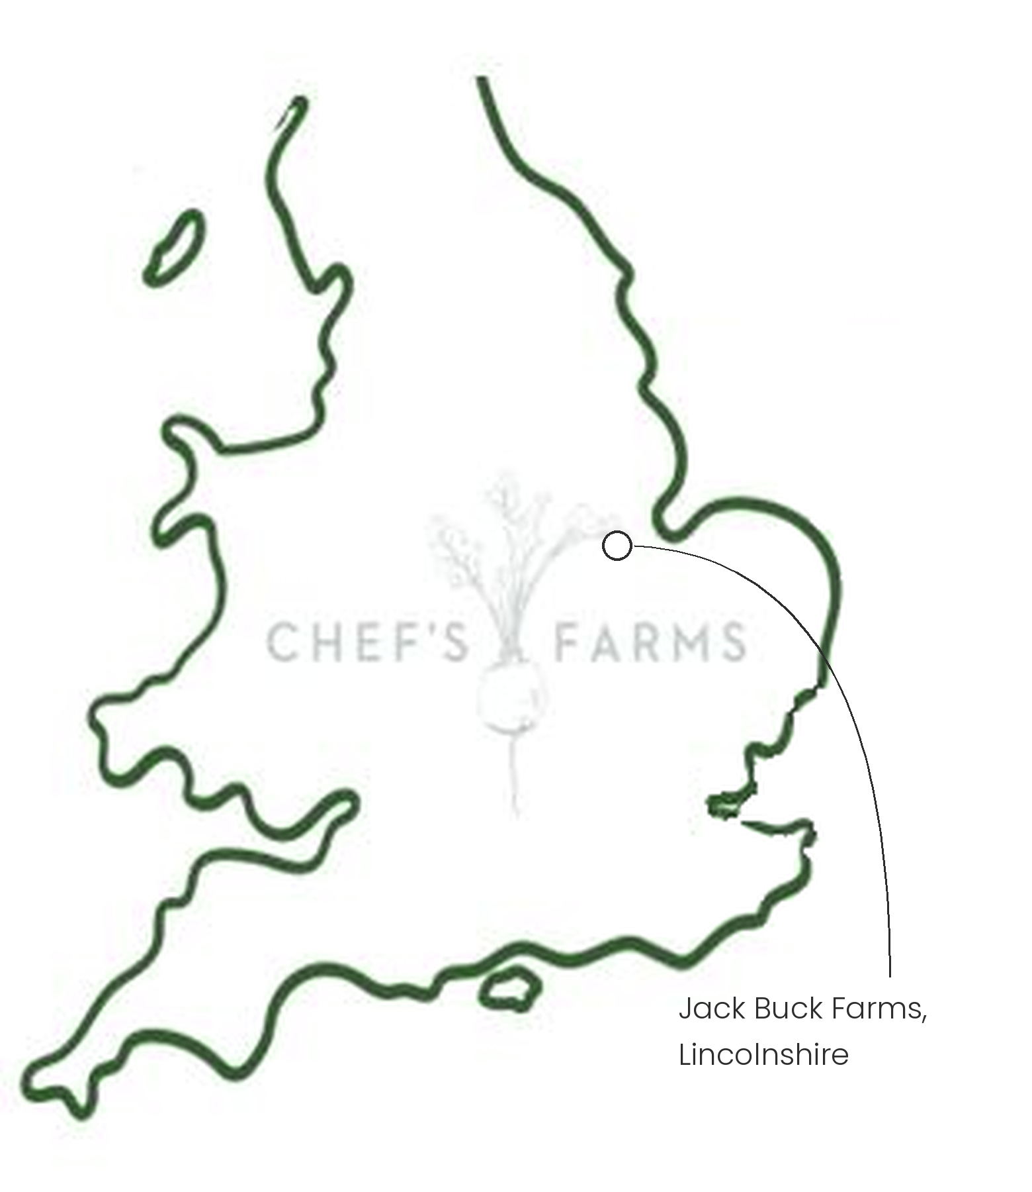
Introduction
Celeriac is a close relative of celery, grown not for its stalks but for the swollen base of its stem. Under the knobbly skin is a creamy white flesh with a gentle, nutty celery flavour.
Farm Information
Our celeriac is grown by Julian Perowne and the team in Lincolnshire.
Lincolnshire's flat, fertile fenland soils are some of the best growing land in the country, and they suit celeriac perfectly. It is a slow, thirsty crop: raised from seed under cover in early spring, planted out in late spring, then left to bulk up through the summer and autumn. Rich soil that holds its moisture gives the roots what they need to grow large, dense and even.
This summer's drought was hard on the crop. But years of good soil management have built soil that holds far more water than heavily degraded ground, so their celeriac was much less badly affected than it would otherwise have been.
Celeriac belongs to the same plant family as carrots, parsnips and parsley, and they share many of the same pests, such as carrot fly. Moving the crop to fresh ground each season as part of a crop rotation stops these pests building up in the soil and keeps the land fertile.
We are proud to work with Julian and the team.
More
Celeriac is harvested from autumn and stores well through the winter, making it a reliable root when other crops are scarce. Peel it thickly, then purée it, roast it whole, or shred it raw for a classic remoulade.
Nutritionally, celeriac is low in calories and a good source of vitamin K, vitamin C and fibre.
Media
See shared album

